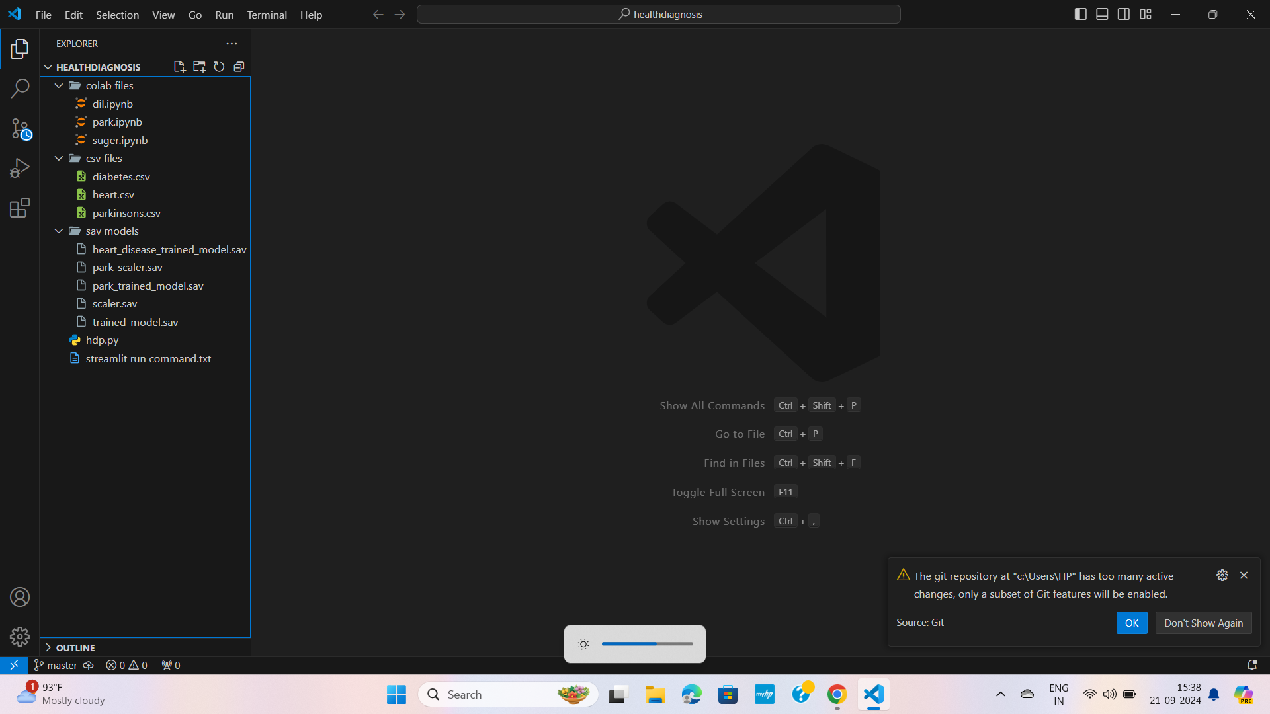

**HEALTH DIAGNOSIS PROJECT**

* **DESCRIPTION :-** *this a health diagnosis project, where a user can easily input the necessary data and according to that they can find out there disease. That whether they have HEART DIASEASE, DIABETES or PARKINSON’S DISEASE. created with concept of DATA ANALYSIS, ML(MACHINE LEARNING).*

*With the help of different languages such as: PYTHON, ANACONDA/ANACONDA NAVIGATOR, SPIDER, STREAMLIT*

*With the help of GOOGLE COLAB for coding the ML concepts, KAGGLE for collecting data for data analysis and other purpose.*

* **DETAILS/DOCS :-** *So in this project inside the folder – HEALTH_DIAGNOSIS, I created 3 other folders – COLAB, CSV, SAV MODELS. Inside this 3 folder I have different files such as :*
* ***COLAB***
* *DIL.IPYNB - (google colab file for heart disease where through different steps it can give the result that whether a patient have heart disease or not)*
* *PARK.IPYNB - (google colab file for parkinson’s disease where through different steps it can give the result that whether a patient have parkinson’s disease or not)*
* *SUGER.IPYNB - (google colab file for parkinson’s disease where through different steps it can give the result that whether a patient have parkinson’s disease or not)*
* ***CSV***
* *DIABETES.CSV – (this is the diabetes data which I download from the website KAGGLE for data analysis purpose)*
* *HEART****.****CSV - (this is the heart data which I download from the website KAGGLE for data analysis purpose)*
* *PARKINSONS.CSV - (this is the parkinson’s data which I download from the website KAGGLE for data analysis purpose)*
* ***SAV MODELS***
* *HEART_DISEASE_TRAINED_MODEL.SAV – (after downloading the CSV files, after writing codes and after getting the output, we need to train the model that whether the model is appropriate for any type of user’s input. After train the model we need to download it as SAV files [Only heart_disease_trained_ model.sav] )*

*(when in any code we need to use STANDERD_SCALER, at that time I need to download the SCALER.SAV file along with normal TRAINED_MODEL.SAV file)*

* *PARK_TRAINED_MODEL.SAV – ( [park_ trained_model.sav + park_scaler.sav ] )*
* *TRAINED_MODEL.SAV {DIABETES} – ( [trained_model + scaler.sav] )*
* ***HDP.PY –*** *It is the python code which I write in the SPIDER so that it can communicate with AVACONDA NAVIGATER and work accordingly along with the trained models.*
* ***STREAMLIT RUN COMMAND.TXT –*** *it is the text which used to run the website. In this text file we store the path details, which should need in the terminal so that we can open our website.*
* **DOWNLOAD/OPEN STRUCTURE OF ALL ELEMENTS :-**
* ***GOOGLE COLAB –*** *write google colab in google chrome -> open 1st link -> new notebook/select your notebook -> change file name -> connect*

***-****>click upload button->upload csv file->write any code -> shift+enter*

* ***After coding Download each 3 disease file’s as ipynb in COLAB FOLDER***
* *It is a cloud based application where we write python programs, It connect our PC’s installed python environment with google’s backend server, RAM,CPU allocated by it, each line is a shell, inside that we run our code where we can write either code/text. For installing anything/library write - ! pip install library_name*
* ***KAGGLE –*** *search Kaggle->open 1st link->sign in/log in in Kaggle/ search for the particular dataset->click on download button*
* ***Download 3 disease’s dataset from Kaggle for data analysis in google colab in CSV FOLDER***
* *Kaggle is an online platform where you can learn data science, find datasets, and compete in machine learning challenges.*
* ***ANACONDA/STREAMLIT/SPYDER –*** *search install anaconda in google chrome -> open 1st link -> Download[64-bit for me] -> install with default settings -> open* ***anaconda navigator*** *from search bar {run as administrator} ->*

*Search* ***install streamlit*** *in anaconda - > open 1st link ->scroll -> copy pip install streamlit & streamlit hello ->after opening click home from left side bar(default)-> in the left side bar click on environment -> click create from the bottom part -> give name(here for me MACHINE_LEARNING-)>create->* from home-> select environment->*install necessary items(****spyder,Qt console*** *etc.)->click environment->click on your environment(here MACHINE_LEARNING)-> right click-> open terminal->paste pip install streamlit->enter->after downloading run streamlit hello->enter->a default webpage will open.*

* *For installing any extra library search in google – library_name pypi->it will give the command to install this library, copy it ->come to anaconda navigator->right click to your environment->open terminal->paste command->enter*
* *Pickle- used to save model as SAV*
* ***DEPLOY MODEL USING STREAMLIT*** *– go to google colab* ->*open google colab file on those you are working(suppose heart.ipynb)->click runtime from upper side bar->click run all-> ->import pickle->for saveing your model as SAV in a variable(exm.- f = ‘trained_model.sav’)->open file through this line of code (pickle.dump(classifier,open(f,’wb’)) [classifier = the variable name with which you saved your trained model]->shift+enter->it will create a file called trained_model.sav->load saved model (for this check code) ->for standard_scaler we need to do similar->save sclaer as sav->load scaler->after loading deploy/train using code(check from code)->after doing all this->in left sidebar right click on trained_model.sav/scaler.sav->download inside SAV MODEL FOLDER*
* ***Do this for all 3 disease save each disease’s SAV files in SAV FOLDER***
* ***UI DESIGN FOR WEBSITE –*** *search pickle pypi ,streamlit pypi, pip install streamlit option menu -> copy command->go to anaconda navigator or run as administrator->click on your environment->open terminal by right clicking on your selected environment->paste copied commands*
* *pip install streamlit option menu – use for creating side bar ion a website*
* ***SPIDER FOR DEPLOYMENT –*** *after installetion ->open spider->click on file from upper side bar->new file->inside the folder where you store all other files, inside that save this spider/python file as file_name.py(here the folder is – HEALTHDIAGNOSIS)->check the full code from hdp.py->import all libreries->load all SAV models by there path->continue with code…….*
* *For declaring path use ‘ \ ’*
* ***STREAMLIT RUN COMMAND :-*** *[open your main folder HEALTHDIAGNOSIS -> right click->new->text document->name it(here streamlit run command.text)->under this file write -> streamlit run “path of the spider/python file”->save](This much already done before)->open anaconda navigator ->select your environment(Machine Learning)->left click on the button ->choose open terminal->paste the text written in – streamlit.text file “path of the spider/python file”->enter->it will open your website where you have your ultimate website*

**-: EXPLANATION OF EACH CODE :-**

**COLAB FOLDER :-**

***HEART.IPYNB***

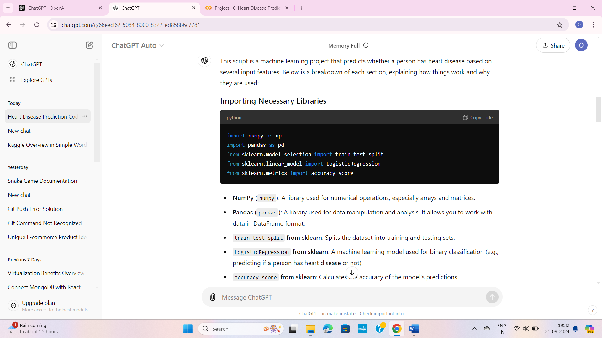

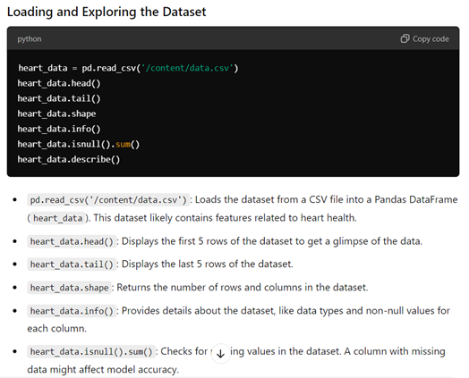

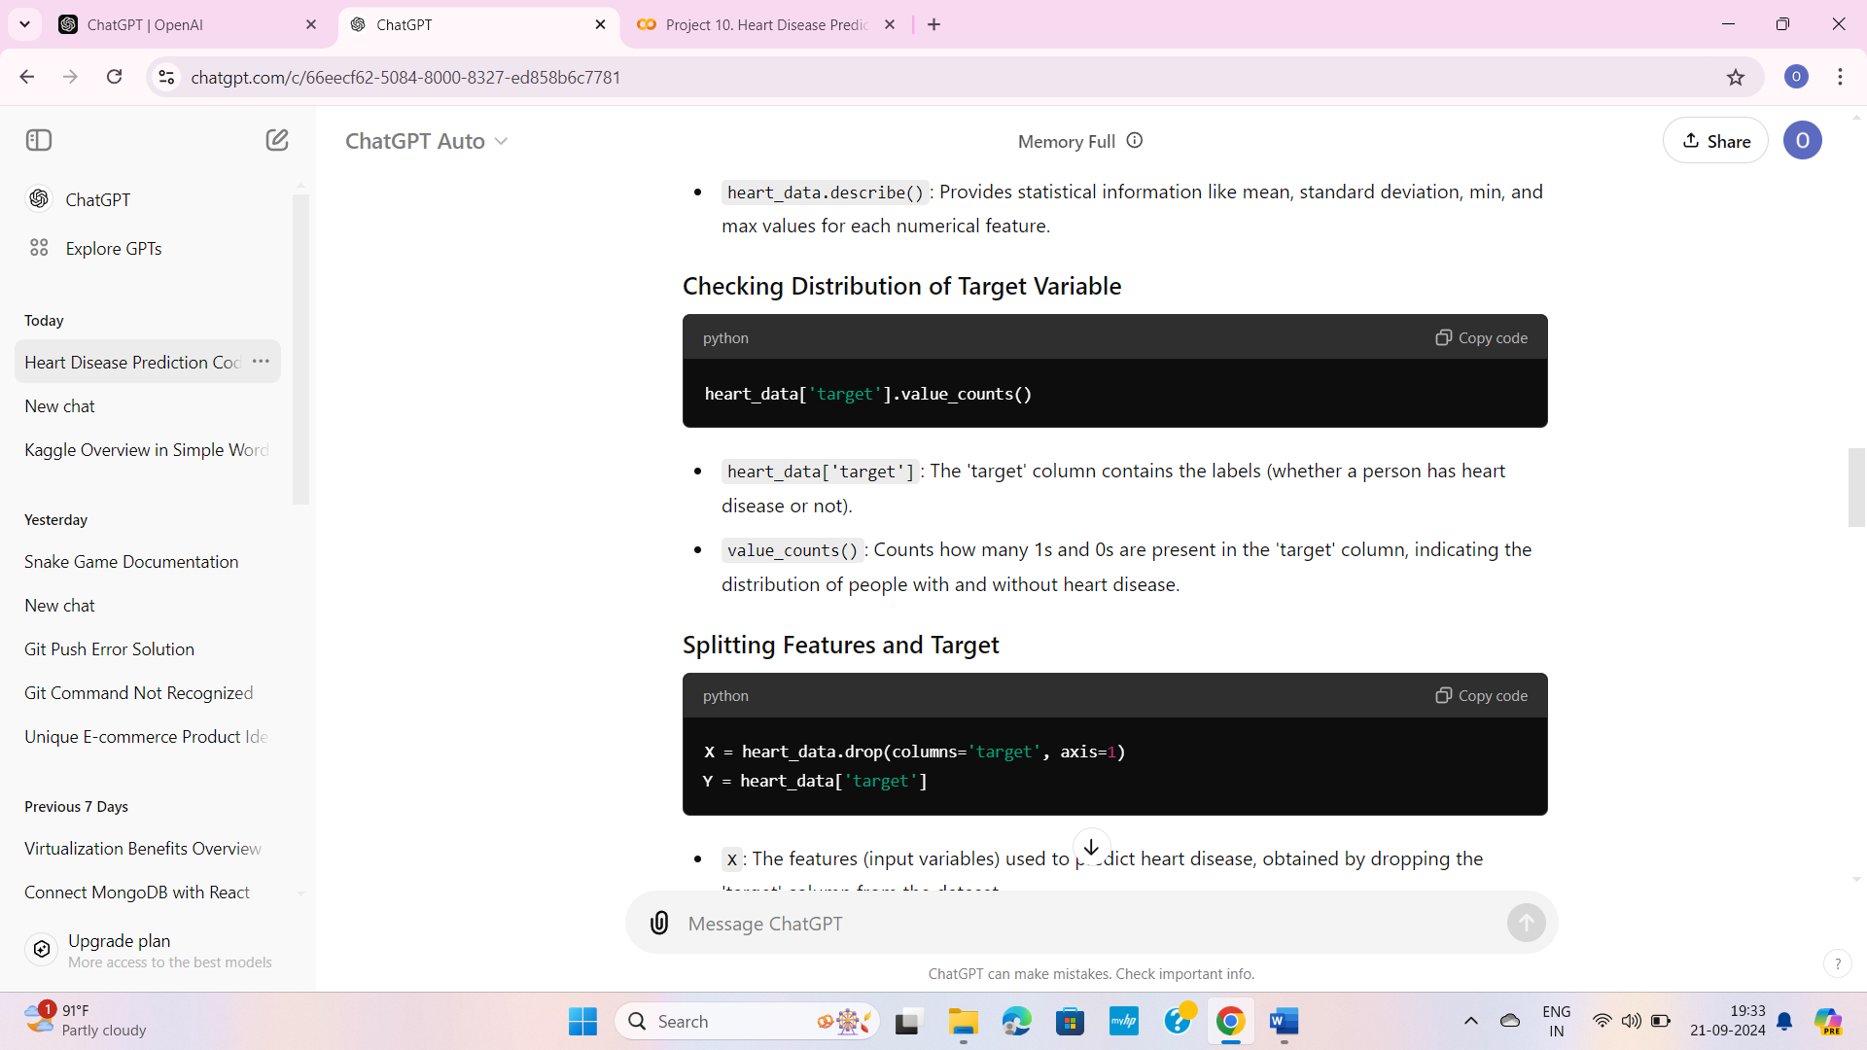

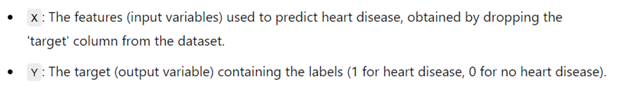

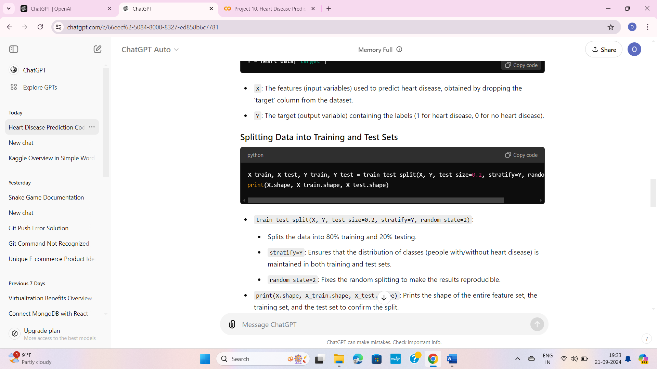

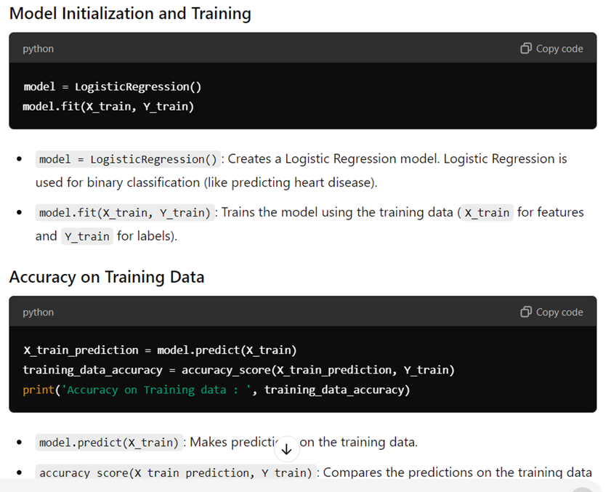

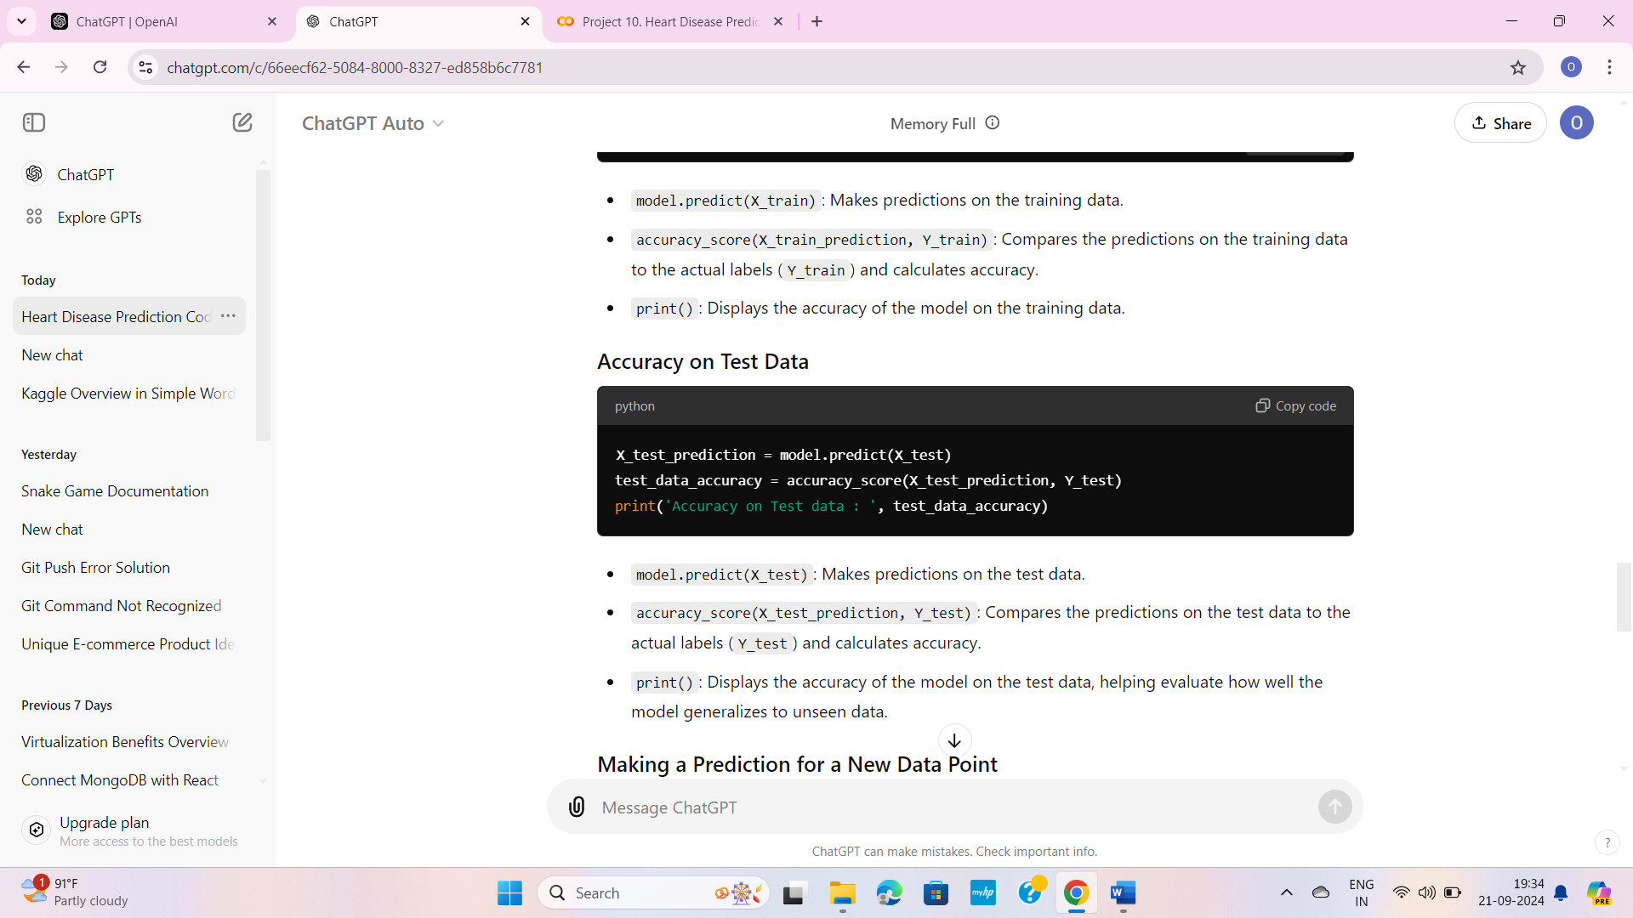

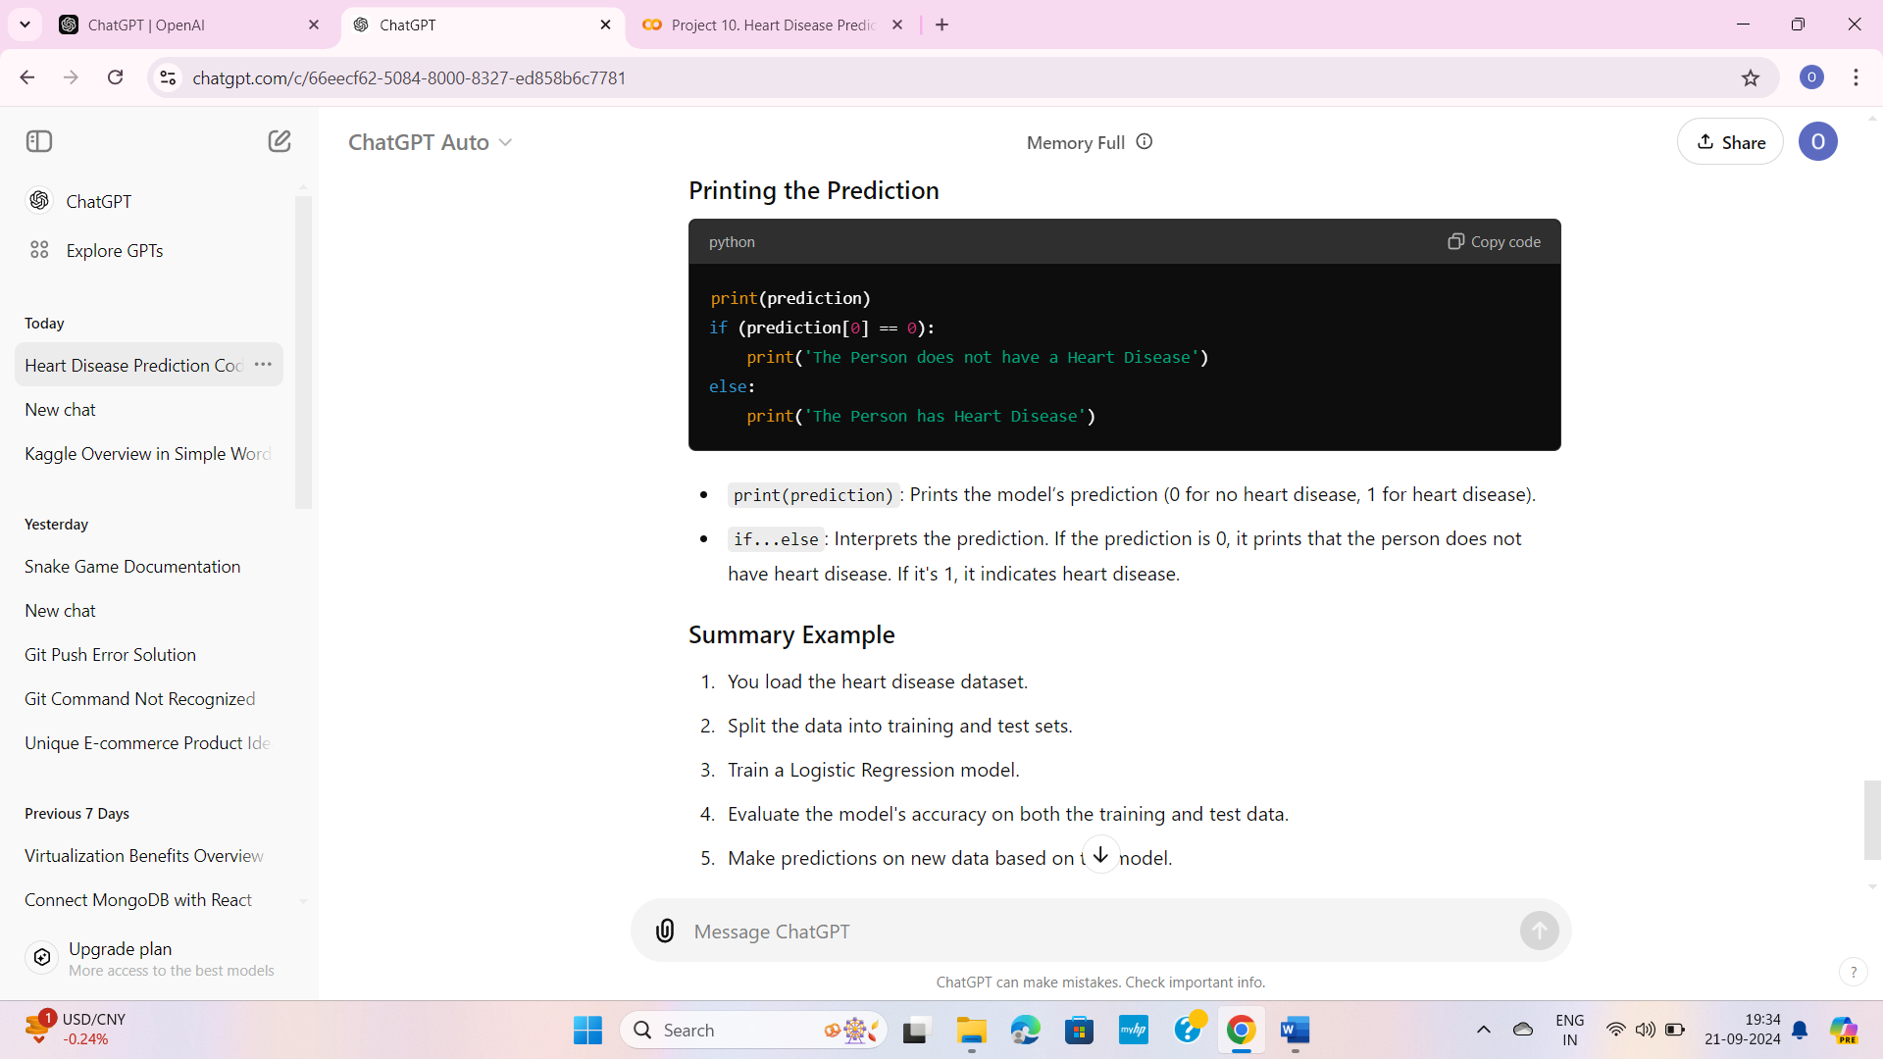

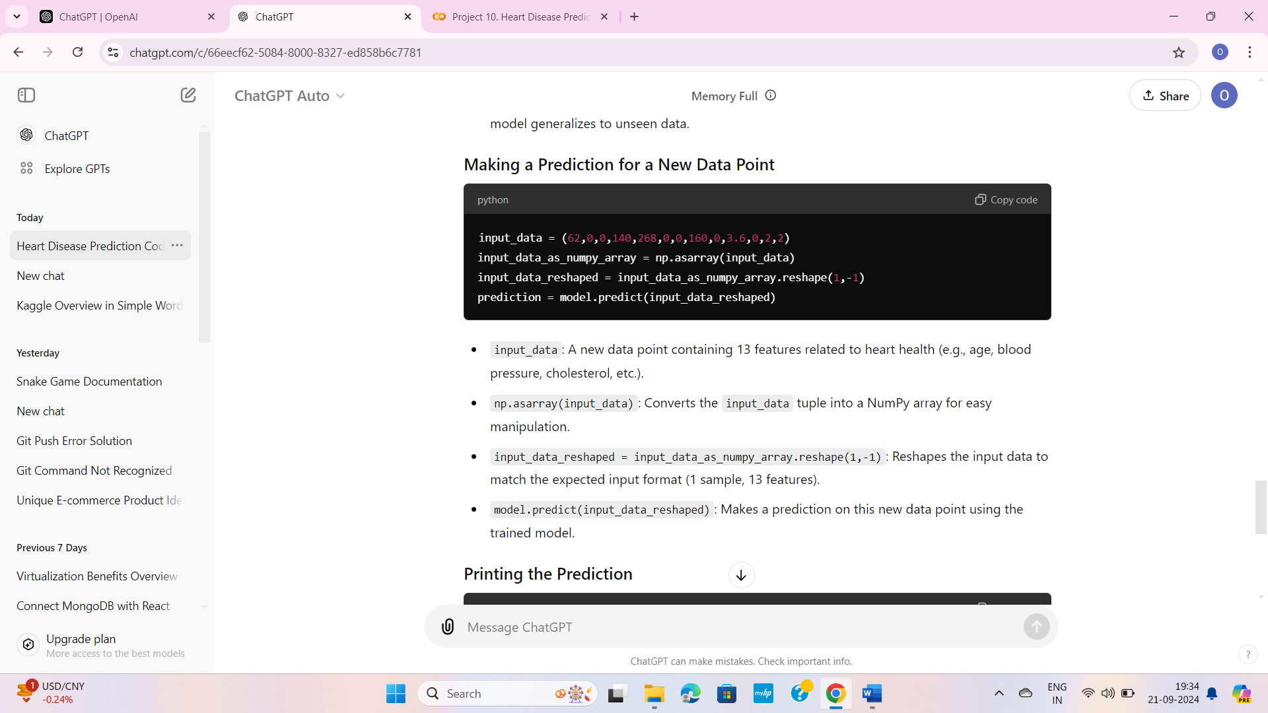

***PARK.IPYNB***

**COLAB FOLDER :-**

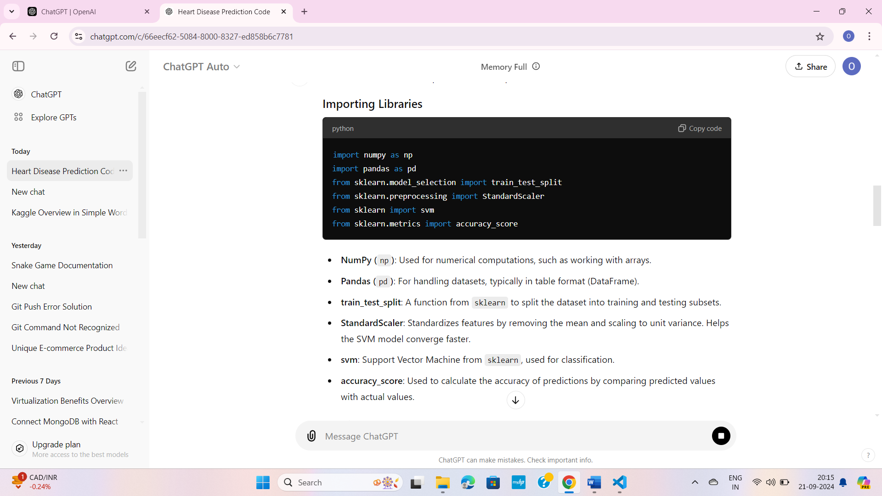

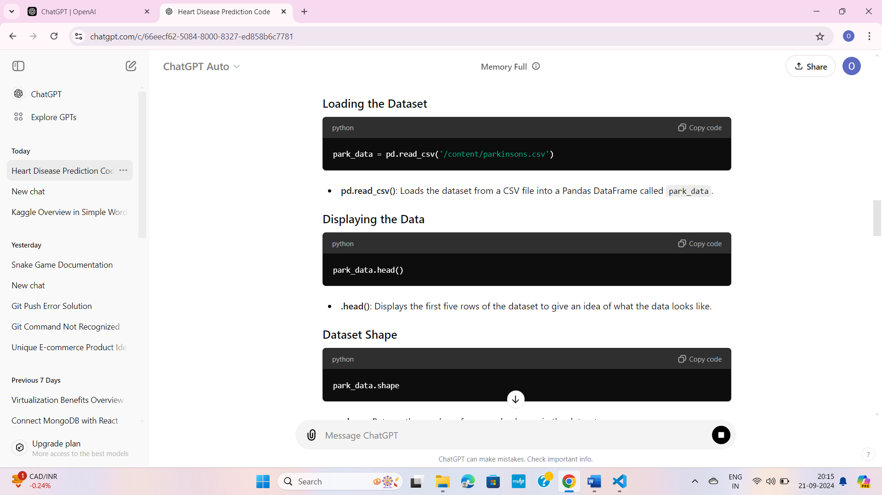

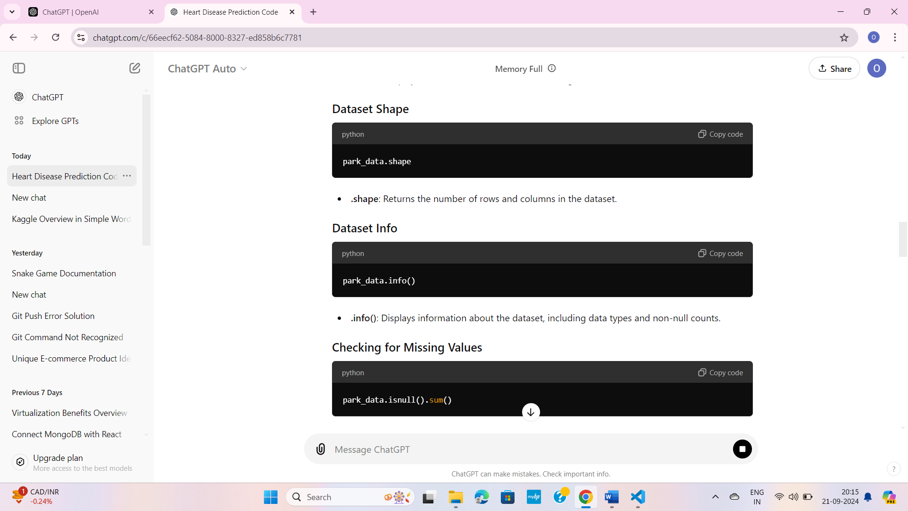

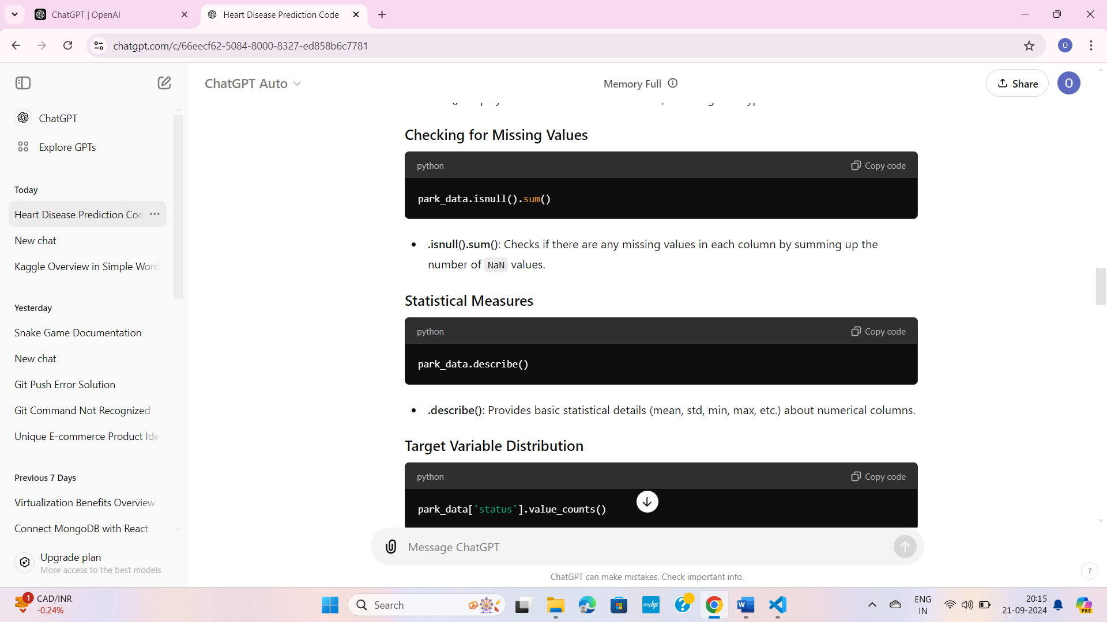

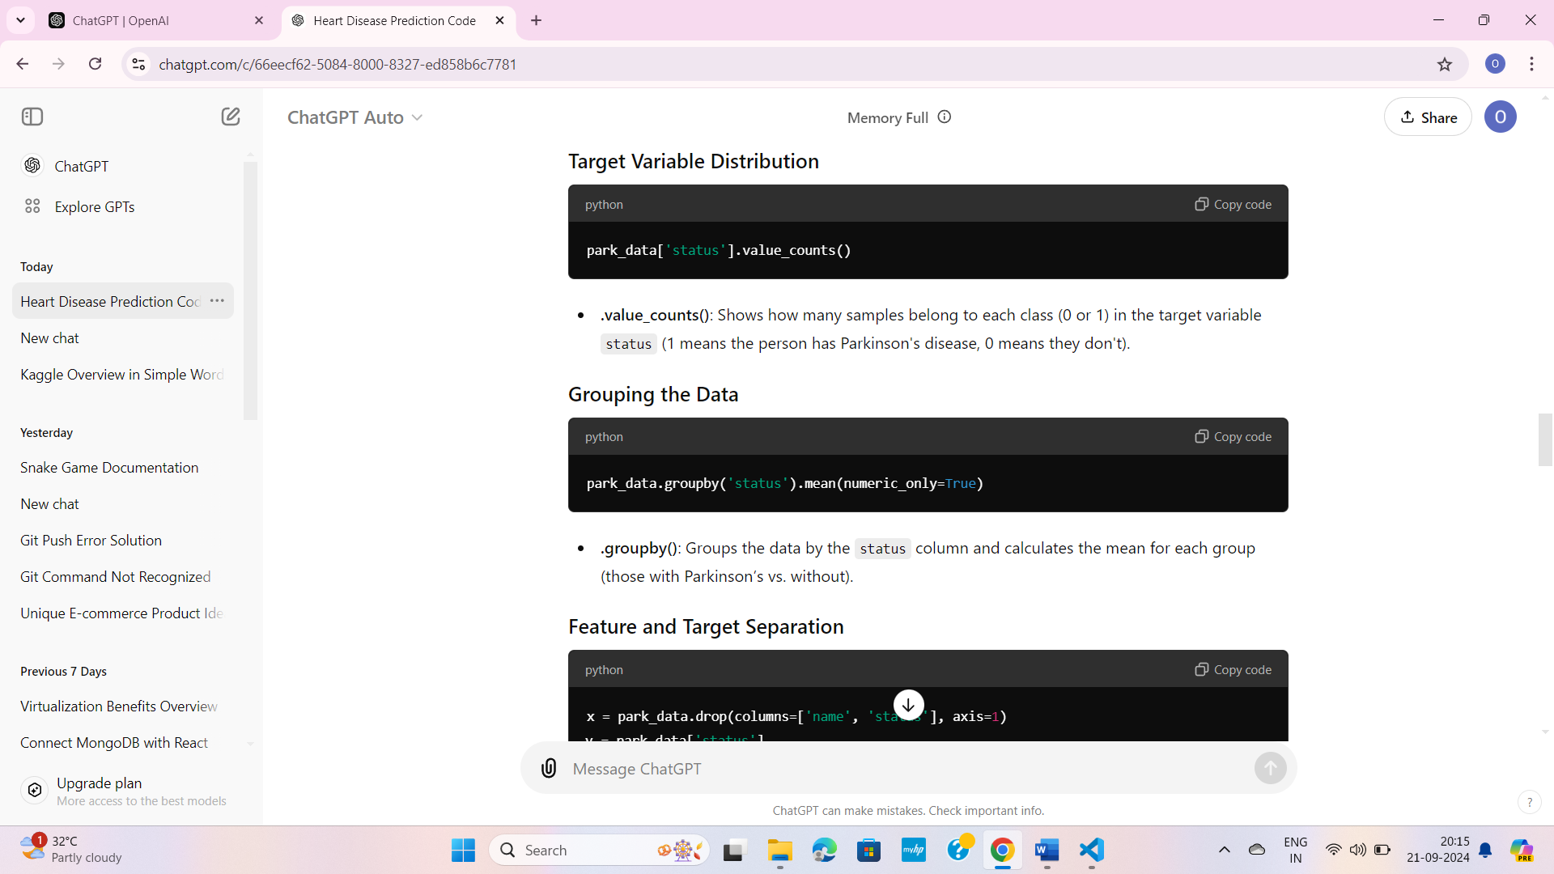

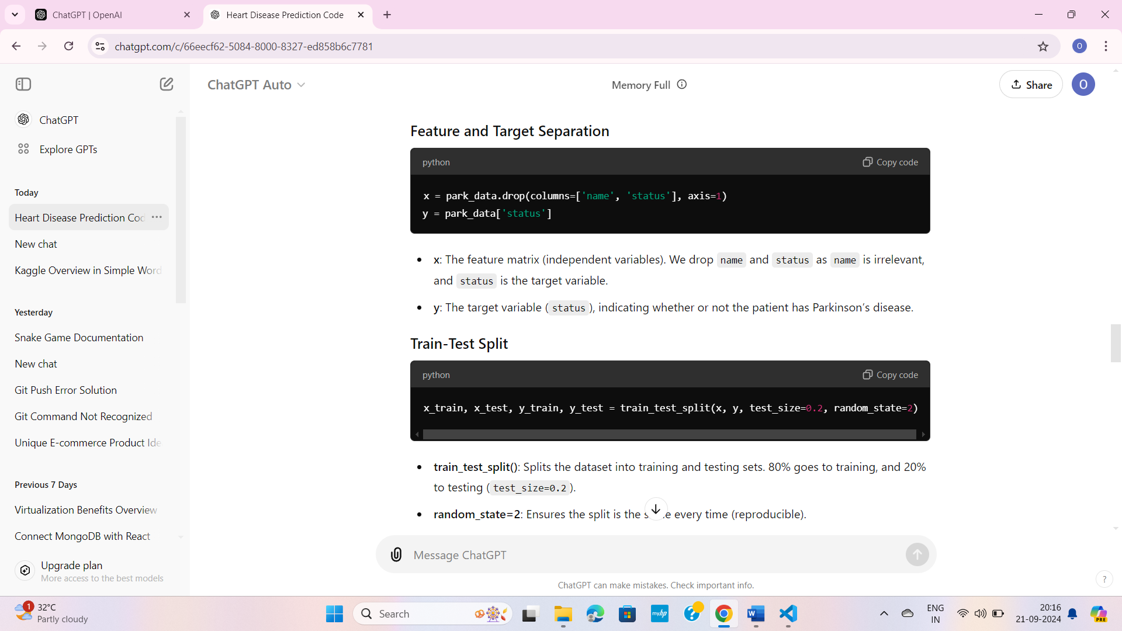

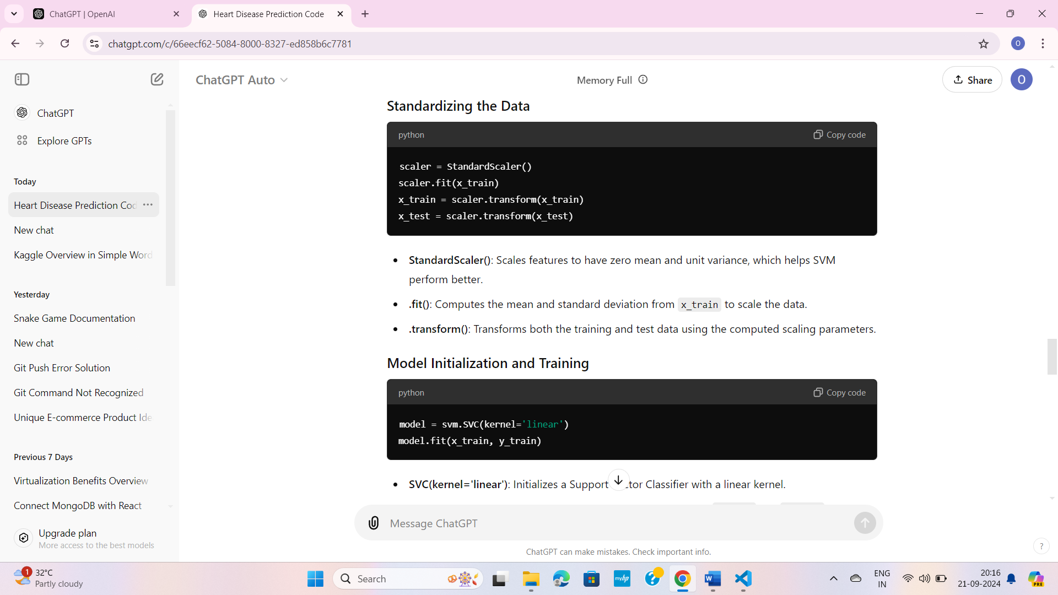

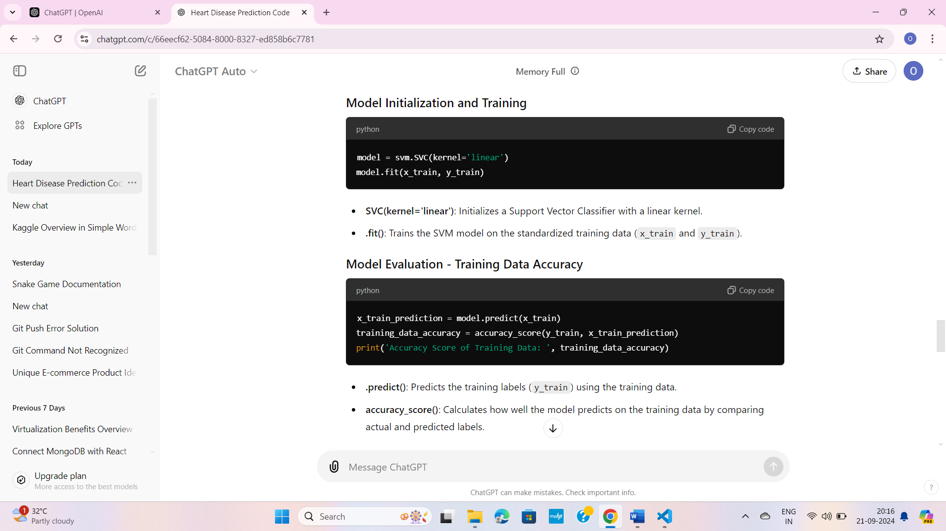

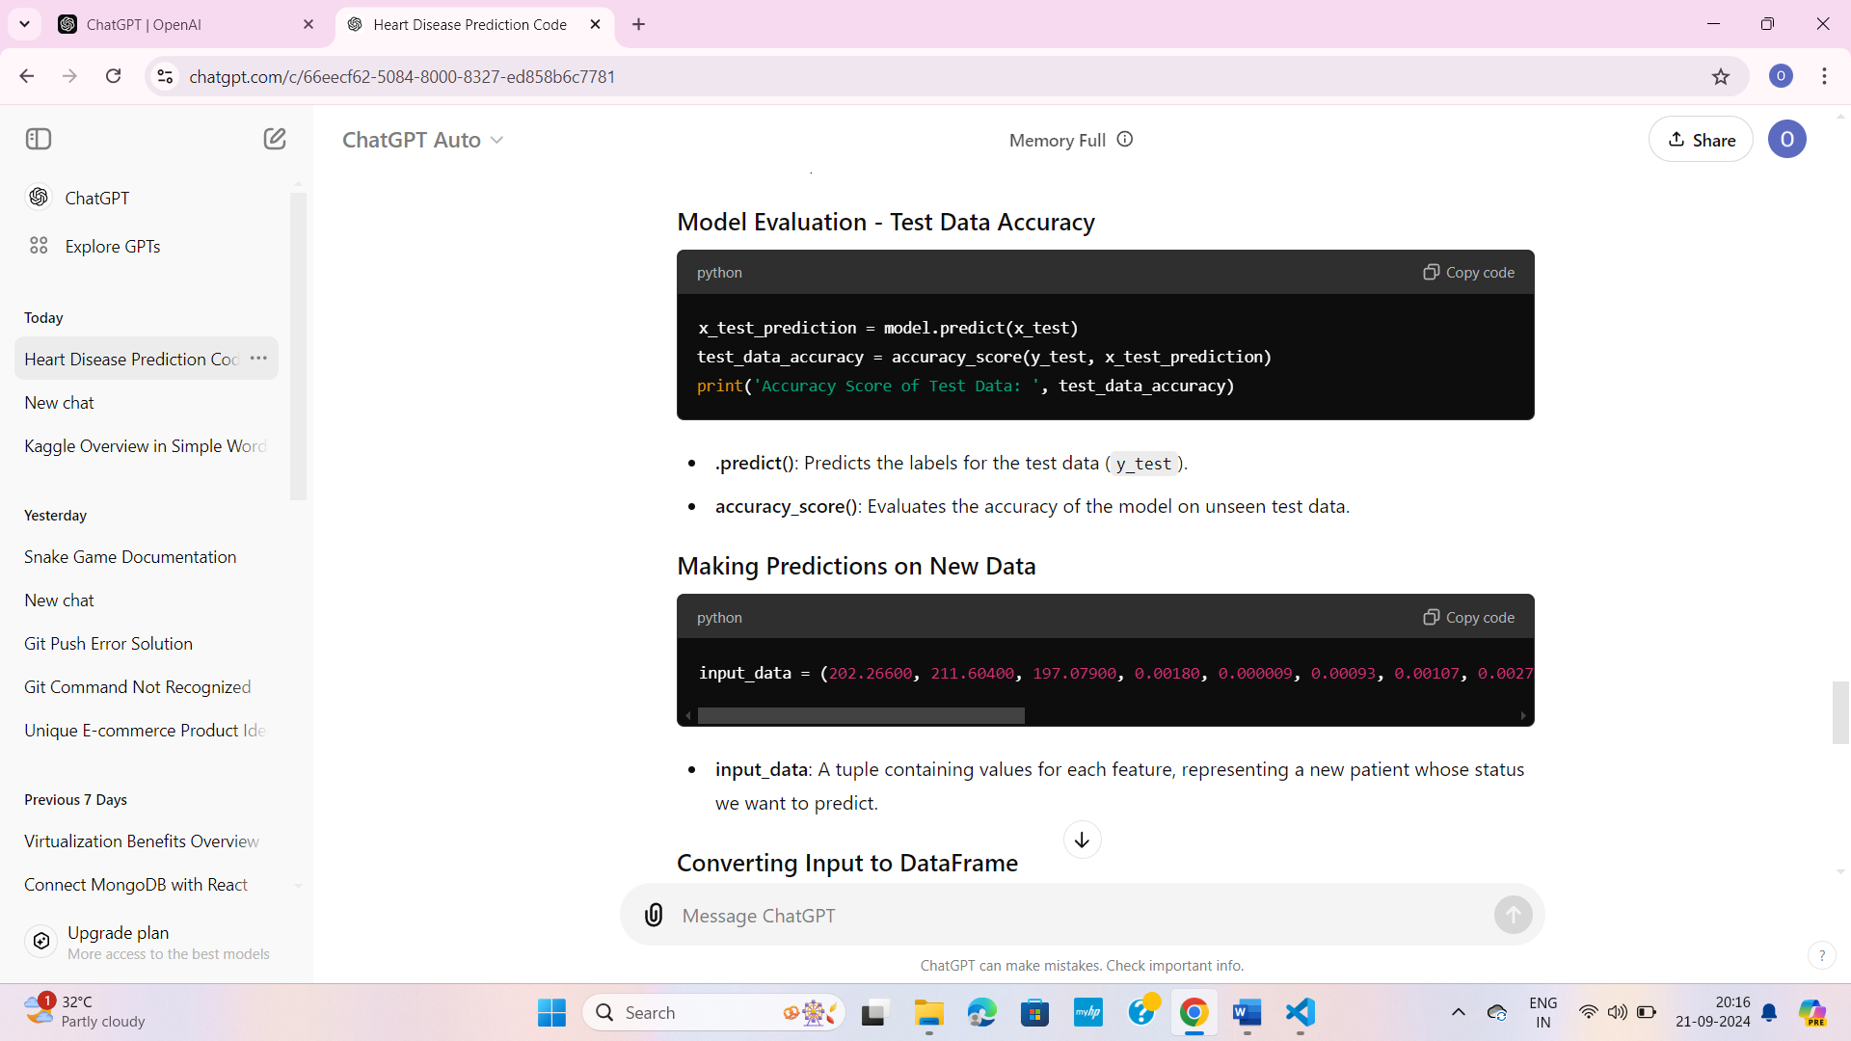

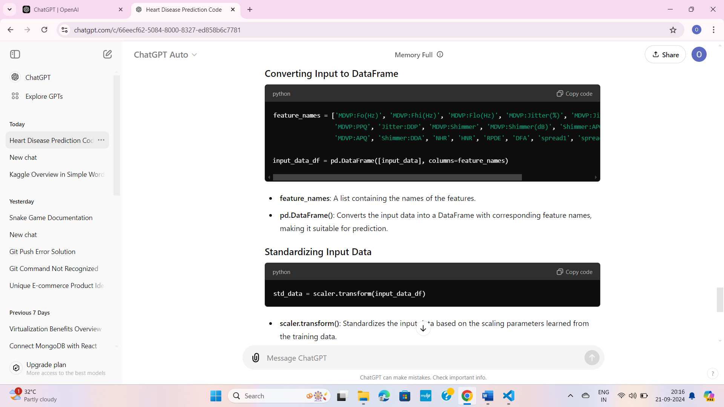

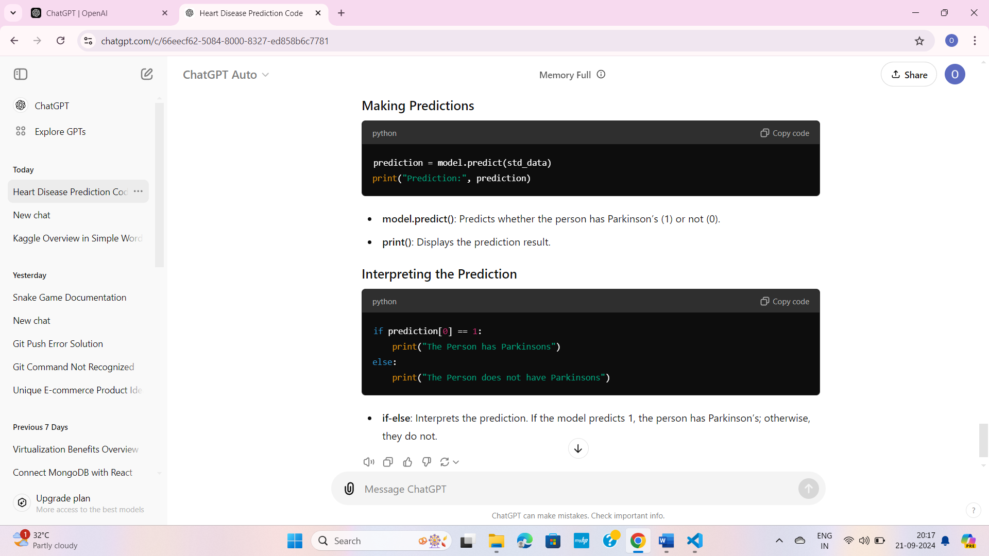

***DIABETES.IPYNB***

**COLAB FOLDER :-**

* ***It is exactly similar like parkinsion’s data prediction check that***

***HDP.PY FILE - CODE***

